**WFM -FINAL PROJECT**

**Login Page:**

**Home Page with login**

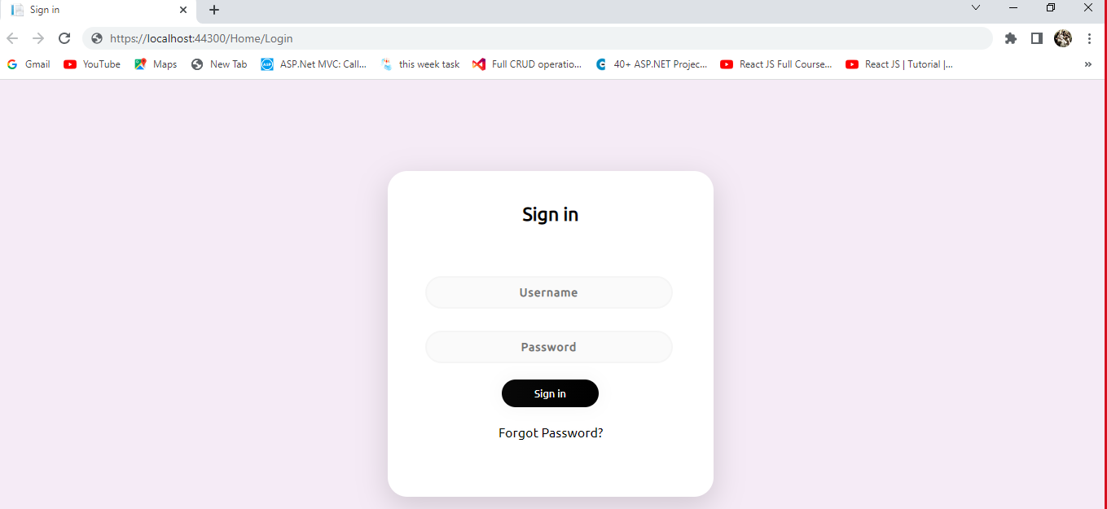

**Manager Login Page View:**

**Once the login is performed successfully the below page is shown**

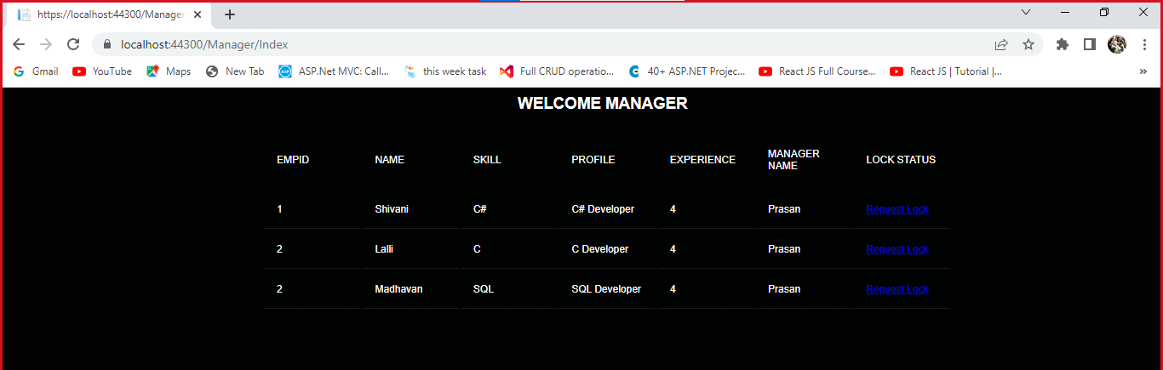

**Manager Page Edit View:**

**After clicking the Lock request button, the below page will be opened.**

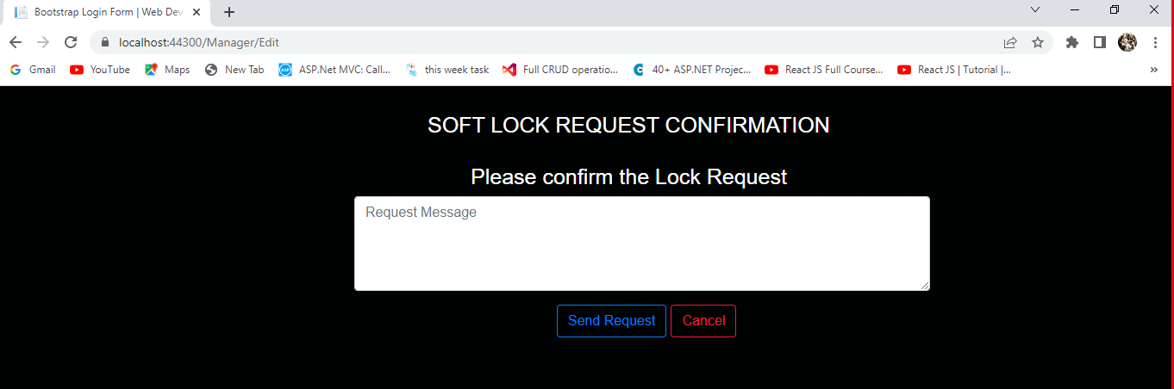

**WFM Manager Page View:**

**With Wfm Member , this below screen will open. It will call the following method.**

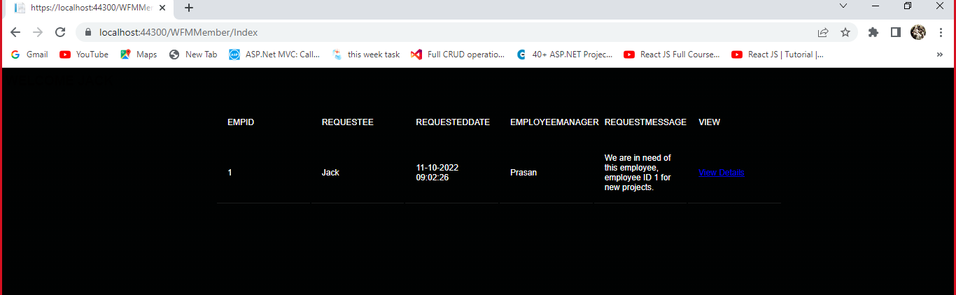

**WFM Manager Edit Page View:**

**On clicking the view details we can view the details**

